Agenda Item : 2/01

= application site



53 & 55 St Michael’s Crescent, Pinner | P/0289/18

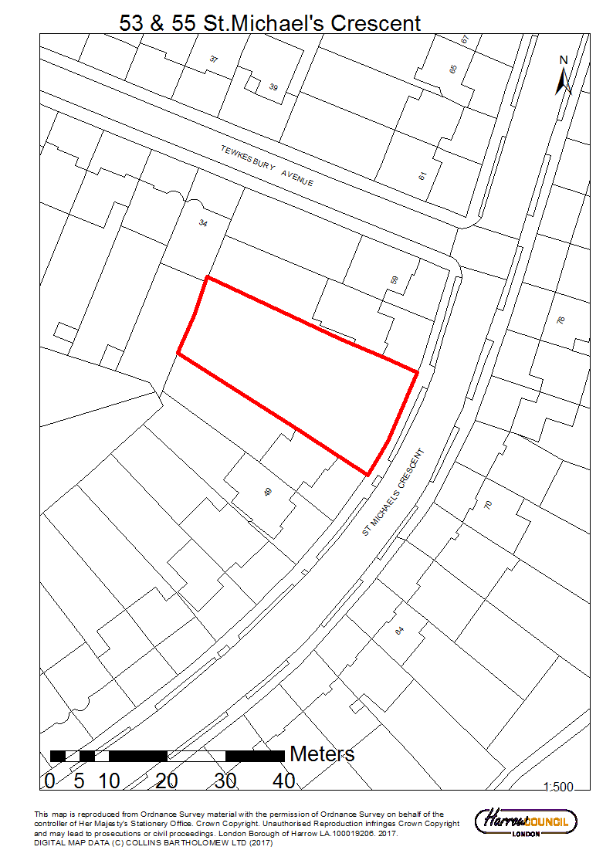

53 & 55 St Michael’s Crescent, Pinner | P/0289/18
LONDON BOROUGH OF HARROW

PLANNING COMMITTEE

30th May 2018

APPLICATION NUMBER: | P/0289/18
VALIDATE DATE: | 12/03/2018
LOCATION: | 53 & 55 ST. MICHAEL’S CRESCENT, PINNER.
WARD: | PINNER SOUTH
POSTCODE: | HA5 5LE
APPLICANT: | MR & MRS PAL AND MR & MRS YAKEEN PATEL
AGENT: | GREENFIELDS ARCHITECTURAL SERVICES
CASE OFFICER: | GRAHAM MANSFIELD
EXPIRY DATE: | 30/04/2018 (EXTENDED EXPIRY: 01/06/2018)
Purpose of Report/Proposal

The purpose of this report is to set out the Officer recommendations to the Planning Committee regarding an application for planning permission relating to the following proposal.

Single storey side to rear extensions and conversion of garages to habitable rooms to both no. 53 and 55 St. Michael's Crescent; associated external alterations to both properties.
RECOMMENDATION

The Planning Committee is asked to:

- agree the reasons for approval as set out this report; and

- grant planning permission subject to the Conditions listed in Appendix 1 of this report

REASON FOR THE RECOMMENDATIONS

The proposed conversion of garages to habitable rooms with installation of windows to the front and single storey side to rear extensions would accord with relevant policy and would not harm the character or appearance of the area or harm the residential amenities of the neighbouring occupiers.

For these reasons, weighing up the development plan policies and proposals, and other material considerations including comments received in response to notification and consultation, this application is recommended for grant.

INFORMATION

This application is reported to Planning Committee due to the applicant being a member of staff employed by Harrow Council.

Statutory Return Type: | E21: Householder Development
Council Interest: | None
Additional Floor Area: | Approx. 82sqm
GLA Community Infrastructure Levy (CIL) Contribution (provisional): | N/A
Local CIL requirement: | N/A
HUMAN RIGHTS ACT

The provisions of the Human Rights Act 1998 have been taken into account in the processing of the application and the preparation of this report.
EQUALITIES

In determining this planning application, the Council has regard to its equalities obligations including its obligations under section 149 of the Equality Act 2010.

For the purposes of this application there are no adverse equalities issues.
S17 Crime & Disorder Act

Policies 7.3.B and 7.13.B of The London Plan and policy DM1 of the Development Management Polices Local Plan require all new developments to have regard to safety and the measures to reduce crime in the design of development proposal. It is considered that the development does not adversely affect crime risk.
LOCAL GOVERNMENT (ACCESS TO INFORMATION) ACT 1985
BACKGROUND PAPERS USED IN PREPARING THIS REPORT:

- Planning Application
- Statutory Register of Planning Decisions
- Correspondence with Adjoining Occupiers
- Correspondence with Statutory Bodies
- Correspondence with other Council Departments
- Nation Planning Policy Framework
- London Plan
- Local Plan - Core Strategy, Development Management Policies, SPGs
- Other relevant guidance

LIST OF ENCLOSURES / APPENDICES:

Officer Report:
Part 1: Planning Application Fact Sheet
Part 2: Officer Assessment
Appendix 1 – Conditions and Informatives
Appendix 2 – Site Plan
Appendix 3 – Site Photographs
Appendix 4 – Plans and Elevations

OFFICER REPORT

PART 1 : Planning Application Fact Sheet

The Site

Address | 53 & 55 St. Michael’s Crescent, Pinner. HA5 5LE
Applicant | Mr & Mrs Pal and Mr & Mrs Yakeen Patel
Ward | Pinner South
Local Plan allocation | No
Conservation Area | No
Listed Building | No
Setting of Listed Building | No
Building of Local Interest | No
Tree Preservation Order | No
Other | Critical Drainage Area

PART 2: Assessment

- SITE DESCRIPTION

  - The subject properties consist of a pair of two storey detached dwellinghouses located on the north east side of St. Michael’s Crescent.

  - The properties are of a typical 1930’s Metroland style and both dwellinghouses have non original garages attached to the side elevations

  - Located to the south west of no. 53 is the non-attached semi no. 51 St. Michaels Crescent. This property sits back from the front elevation of no. 53 owing to the bend in the road.

  - No. 51 has not been extended to the rear, but has a lean-to extension attached to its north east flank elevation.

  - Located to the north west of no. 55 is non-attached semi no. 57 St Michaels Crescent. This property sits at a higher ground level and owing to the bend in the road, sits behind that of the application property.

  - No. 57 benefits from a single storey side to rear extension and retains a garage adjacent to the application site.

1.6 No. 55 has had previous permissions for a single storey rear extension and two storey side/rear extensions. However, neither of these permissions was ever implemented.

1.7 The rear gardens of both no. 53 and 55 rises in gradient to the rear with the side boundary of no. 34 Tewkesbury Drive abutting the rear boundary of no. 53 and 55.

1.8 The site is located in a critical drainage area and there are no other site constraints.

- PROPOSED DETAILS

2.1 The proposal is to convert the existing garages on both 53 and 55 into a habitable rooms and insert a window on the front elevation of each property. The proposal would also include a single storey side to rear extension to both no. 53 and 55 St. Michaels Crescent

2.2 The proposed single storey side to rear extension would be attached to the previously extended rear kitchen, with a small infill element adjacent to the common boundary with no. 57.

2.3 The proposed single storey rear elements on each property would be 4.3m in depth form the existing rear wall and would feature a flat roof at a maximum height of 3.0m

2.4 It is proposed to insert a glazed window and bi-folding doors into the rear elevations of no. 53 and 55, together with the insertion of roof lanterns into each roof.

2.5 It is proposed to make some external alterations to the garage roofs on both no. 53 and 55 by attaching a false pitch roofs above the former garages.

- HISTORY – NO. 53 ST. MICHAEL’S CRESCENT

3.1 HAR/3179; Erect Domestic Garage
Granted; 12/05/1950

3.2 LBH/11875;
Erection of Single Storey Kitchen Extension at Rear of Garage
Granted; 28/05/1976

3.3 LBH/34695
Single Storey Rear Extension
Granted; 26/04/1988

3.4 P/1062/05/DFU
Single and Two Storey Side and Rear Extension
Granted; 28/06/2005

3.5 HISTORY – NO. 55 ST. MICHAEL’S CRESCENT

3.6 P/1756/17
Single Storey Side to Rear Extension; Conversion of Garage to Room with Installation of window to front; Alterations to the roof to form end gable; Rear Dormer with Juliette balcony and two rooflights in front roofslope.
Refused: 13/07/2017
Reasons for Refusal:

1. The proposed rear dormer by reason of its excessive scale and lack of containment within the rear roofslope would add excessive mass and bulk to the existing roof resulting in a disproportionate and overbearing addition to the original dwellinghouse which would be harmful to the character and appearance of the host dwellinghouse and the visual amenities of the area contrary to policy 7.4.B of The London Plan 2016, policy CS1.B of the Harrow Core Strategy 2012 and policy DM1 of the Development Management Policies Local Plan 2013 and the adopted Supplementary Planning Document: Residential Design Guide (2010).
2. The proposed Juliette balcony by reason of its siting and proximity to the neighbouring properties would result in a development that would give rise to direct, perceived overlooking and general disturbance to neighbouring properties. The proposal would be detrimental to the privacy of no’s 51 and 55 St. Michael’s Crescent. The proposal is contrary to policies 7.6.B of The London Plan (2016), policy CS1.B of The Harrow Core Strategy 2012, policies DM1 of the Development Management Policies Local Plan 2013 and paragraph 6.73 of the adopted Supplementary Planning Document: Residential Design Guide 2010.
3. The proposed single storey rear extension by reason of its excessive rearward projection would result in a disproportionate development which would appear visually obtrusive, and would give rise to a loss of outlook, overbearing impacts, and overshadowing to the rear of no. 55 St Michael’s Crescent which would be harmful to the residential amenities of the occupiers of this neighbouring property. The proposal is contrary to policies 7.4B and 7.6.B of The London Plan 2016, policy CS1. B of the Harrow Development Management Policies Local Plan, policy DM1 of the Development Management Policies Local Plan 2013 and the adopted Supplementary Planning Document: Residential Design Guide 2010.

3.7 P/3541/17
Certificate Of Lawful Development (Proposed): Alterations To Roof To Form End Gable, Rear Dormer with Juliette Balcony; Two Rooflights In Front Roofslope
Granted: 31/10/2017

- CONSULTATION

4.1 A total of 3 consultation letters were sent to neighbouring properties
regarding this application. The overall public consultation period expired on 27th April 2018.

4.2 Adjoining Properties

Number of Letters Sent | 3
Number of Responses Received | 0
Number in Support | 0
Number of Objections | 0

4.6 Statutory and Non Statutory Consultation

4.7 The following consultations have been undertaken:
- Pinner Association.

4.8 External Consultation

4.9 A summary of the consultation responses received along with the Officer comments are set out in the Table below.
Consultee | Summary of Comments | Officer Comments
Pinner Association. | No Response Received | Noted

4.10 Internal Consultation

4.11 A summary of the consultation responses received along with the Officer comments are set out in the Table below.

Consultee | Summary of Comments | Officer Comments
LBH Drainage Authority | No objections. The application is not within a flood risk area, and as such would not lead to exacerbate potential flood risk on the site or wider area. A Sustainable Urban Drainage informative is recommended. | Noted

- POLICIES

5.1 Section 38(6) of the Planning and Compulsory Purchase Act 2004 requires that:

‘If regard is to be had to the Development Plan for the purpose of any determination to be made under the Planning Acts, the determination must be made in accordance with the Plan unless material considerations indicate otherwise.’

In this instance, the Development Plan comprises The London Plan 2016, The Harrow Core Strategy 2012 [CS], Harrow and Wealdstone Area Action Plan (AAP) 2013, the Development Management Policies Local Plan 2013 [DMP], the Site Allocations Local Plan SALP 2013 [SALP].

While this application has been principally considered against the adopted London Plan (2016) policies, some regard has also been given to relevant policies in the Draft London Plan (2017), as this will eventually replace the current London Plan (2016) when adopted and forms part of the development plan for the Borough.

The document has been published in draft form in December 2017. Currently, the Mayor of London is seeking representations from interested parties/stakeholders, before the draft Plan is sent to the Secretary of State for Examination in Public, which is not expected to take place until the summer of 2019. Given that that the draft Plan is still in the initial stages of the formal process it holds very limited weight in the determination of planning applications.

Notwithstanding the above, the Draft London Plan (2017) remains a material planning consideration, with relevant polices referenced within the report below and a summary within Informative 1.

- APPRAISAL

6.1 The main issues are;
Character and Appearance
Residential Amenity – Neighbouring occupiers
Development and Flood Risk
Highways & Parking

6.2 Character and Appearance

6.2.1 Policy 7.4 (B) of the London Plan requires that buildings, streets and open spaces should provide a high quality design response that has regard to the pattern and grain of the existing spaces and streets in orientation, scale, proportion and mass.

6.2.2 Core Policy CS1.B specifies that ‘All development shall respond positively to the local and historic context in terms of design, siting, density and spacing, reinforce the positive attributes of local distinctiveness whilst promoting innovative design and/or enhancing areas of poor design; extensions should respect their host building.’

6.2.3 Policy DM1 of the DMP gives advice that ‘’all development proposals must achieve a high standard of design and layout. Proposals which fail to achieve a high standard of design and layout, or which are detrimental to local character and appearance, will be resisted.’’ The Council has adopted a Supplementary Planning Document (SPD) on Residential Design (2010), which gives design guidance and requires extensions to harmonise with the scale and architectural style of the original dwellinghouse. Substantial weight is accorded to the SPD as a material planning consideration.

6.2.4 The proposed garage conversions would result in the removal of the existing garage doors and a replacement with a casement window. The subject properties are not in a conservation area and the new window would match the fenestration of the existing houses. The overall street scene is varied and does not have a prevailing pattern of built in garages. Therefore, the impact on the street scene and the host pair of semi-detached houses would be acceptable.

6.2.5 It is proposed to make external changes to the roofs as part of the garage conversions. It is proposed to attach a false pitched roof to the front of the existing garage at both no. 53 and 55. Paragraph 6.16 states that false-pitched roofs should be avoided where they would be intrusive on the streetscene. However, in this instance the proposed roof alterations would be effectively screened by the neighbouring garages at no’s 51 and 57 St. Michaels’ Crescent respectively. Therefore the impact of this element of the proposal would have an acceptable impact on the character of the streetscene.

6.2.6 The proposed side element at no. 55 would effectively fill in the area between the existing kitchen and the common boundary with no. 57, at a depth of 3.0m and width of 1.0m. Therefore it is considered that the proposed side element would be a modest and proportionate addition to the existing dwellinghouse.

6.2.7 The proposed side element at no. 53 would effectively infill an area between the existing kitchen and the common boundary with no. 51, at an area of approx. 1.5m. Therefore it is considered that the proposed side element would be a modest and proportionate addition to the existing dwellinghouse.

6.2.8 The existing properties are un-extended at the rear. In terms of character, at a depth of 4.3m, the proposed single storey rear extensions would not comply with paragraph 6.59 of the adopted residential design guide, which recommends a maximum depth of 3.0m for single storey rear extensions on semi-detached properties. However, it is considered that the proposed single storey rear extension due to is acceptable height and flat roof design would not appear as a disproportionate or bulky addition to the existing dwellinghouse. Overall, it is considered that the proposed single storey rear extensions would appear as subservient additions to the pair of semi-detached dwellinghouses

6.2.9 Condition 3 of this permission requires that all materials match the existing building to ensure harmonious extensions.

6.2.10 Subject to this condition, the development would accord with the relevant policies of the development plan and the Council’s adopted SPD: Residential Design Guide 2010.

6.3 Residential Amenity – Neighbouring Occupiers

6.3.1 Policy DM1 of the Development Management Policies Local Plan states that ‘all development and change of use proposals must achieve a high standard of privacy and amenity. Proposals that would be detrimental to the privacy and amenity of neighbouring occupiers, or that would fail to achieve satisfactory privacy and amenity for future occupiers of development, will be resisted

6.3.2 In terms of the proposed conversion of the garage, the replacement of the garage doors with casement windows would offer views of the public domain and would not therefore harm neighbouring amenity. The development would therefore accord with development plan policies in respect of amenity.

6.3.3 The proposed single storey side infill extension would be adjacent to the common boundary with no. 57 St. Michaels Crescent. The application site is at a lower ground level than no. 57, considering this and the fact that no. 57 also has a side extension adjacent to the boundary with no. 55 would ensure no undue impacts would occur to the occupants of no. 57 in terms of residential amenity.

6.3.4 It is noted that there is a flank window on the facing flank of no. 57. However, this window serves a utility room and would not be protected source of light. As such it is considered that the proposed single storey side element of the proposal would have an acceptable impact on the occupiers of no. 57 in terms of light, overshadowing and outlook.

6.3.5 As stated in section one of the report, the proposed single storey rear element would be 1.3m over that recommended by paragraph 6.59 of the Residential Design Guide. However, due to the fact that no. 55 is set at a lower ground level and that there is a staggered building line between no. 55 and 57, the proposed 4.3m deep single storey rear extension would not be visible from the extended rear of no. 57.

6.3.6 In terms of the proposed single storey rear element at no. 53, the proposed single storey rear extension would extend 4.3m in depth adjacent to the common boundary with no. 51 St Michaels’ Crescent. No. 51 is not extended at the rear, however, there is a staggered building line between the two properties.
The original rear elevation of no. 51 is set back from the application property by approximately 1.5m. As such the exposed 2.8m south west flank wall of the proposed single storey rear extension is considered not to unduly harm the occupants of no. 51 in terms of outlook, daylight and overshadowing.

6.3.7 The proposed single storey side to rear extension does not seek any flank windows facing No. 53 or 57 St. Michael Crescent. It is considered reasonable that a condition be attached to ensure that no windows are able to be inserted into this flank elevation without the prior approval from the Local Planning Authority. This is secured by condition 5.

6.3.8 The proposed single storey side to rear extension does not seek any flank windows facing No. 51 or 57 St. Michael Crescent. It is considered reasonable that a condition be attached to ensure that no windows are able to be inserted into this flank elevation without the prior approval from the Local Planning Authority. This is secured by condition 5.

6.3.9 To the rear of the application properties at 53 and 55 is the southern boundary of no.34 Tewkesbury Avenue. The proposed single storey rear extensions would be over 20.0m from this property. As such, it is considered that the proposed extensions would not give rise to any harm to the occupants of no. 34 Tewkesbury Avenue to the rear of the site.

6.3.10 Subject to conditions ensuring that the roofs of the proposed extensions are not used as a balconies (Condition 4) and that no further flank windows would be inserted (Condition 5) to ensure the privacy of neighbouring occupiers is maintained, the development would therefore accord with development plan policies in respect of amenity.

6.4 Development and Flood Risk

6.4.1 It is noted that both sites are not located within a known flood risk area, other than the critical drainage area. The Engineering Drainage Section in their response has no objection to the scheme, notwithstanding the objection received. However, they have recommended that an informative be added regarding Sustainable Urban Drainage for the site. Subject to this informative, the proposed development would accord with relevant policy and be therefore acceptable.

6.5 Highways & Parking

6.5.1 The proposal would result in the loss of the existing garages at both properties. The Council’s SPD recommends when considering proposals for front extensions a minimum driveway depth of 4.8m should be retained to allow sufficient parking space (paragraph 6.35). The forecourts of no. 53 and 55 would retain parking space for one vehicle. The number of parking spaces that would be retained would be in accordance with the maximum parking standards set out under policy 6.13 of the London Plan (2016). On this basis, the proposal would give rise to no conflicts with policy DM 42 of the DMP or the London Plan policy 6.13.

7.0 CONCLUSION AND REASONS FOR APPROVAL

7.1 The proposed conversion of garages into habitable rooms, single storey side to rear extensions and associated external alterations would accord with relevant policy and would not harm the character or appearance of the area or harm the residential amenities of neighbouring occupiers.

7.2 For these reasons, weighing up the development plan policies and proposals, and other material considerations including comments received in response to notification and consultation, this application is recommended for grant.

APPENDIX 1: Conditions and Informatives

Conditions
1 | Timing  The development hereby permitted shall be begun before the expiration of three years from the date of this permission.  REASON: To comply with the provisions of Section 91 of the Town and Country Planning Act 1990.
2 | Approved Plans and documents  The development hereby permitted shall be carried out and retained in accordance and with the following approved plans and documents: Site Plan; ST MICHAELS/01; ST MICHAELS/02; ST MICHAELS/03; ST MICHAELS/04 REVISION A; ST MICHAELS/05  REASON: For the avoidance of doubt and in the interests of proper planning.
3 | Materials to Match Existing  The materials to be used in the construction of the external surfaces of the extension hereby permitted shall match those used in the existing building.  REASON: To safeguard the character and appearance of the area
4  5 | No Balcony  The roof area of the extension hereby permitted shall not be used as a balcony, roof garden or similar amenity area without the grant of further specific permission from the local planning authority.  REASON: To safeguard the residential amenities of neighbouring residents  Flank Windows and Doors  Notwithstanding the provisions of the Town and Country Planning (General Permitted Development) Order 2015 (or any order revoking and re-enacting that order with or without modification), no windows, doors or other openings shall be installed in the flank walls of the development hereby permitted without the prior permission in writing of the local planning authority.  REASON: To safeguard the amenity of neighbouring residents
Informatives
1 | Policies
The following policies are relevant to this decision:

The National Planning Policy Framework (2012)
The Draft London Plan 2017:
D1, D2, D3

The London Plan 2016:
7.4.B Local Character
7.6.B Architecture

The Harrow Core Strategy 2012:
CS1.B Local Character

Harrow Development Management Policies Local Plan 2013:
DM1 Achieving a High Standard of Development
DM10 On Site Water Management and Surface Water Attenuation
DM22 Trees and Landscaping

Supplementary Planning Document - Residential Design Guide 2010

2 | Considerate Contractor Code of Practice
The applicant's attention is drawn to the requirements in the Considerate Contractor Code of Practice. In the interests of minimising any adverse effects arising from building operations, the limitations on hours of working are as follows:
0800-1800 hours Monday - Friday (not including Bank Holidays)
0800-1300 hours Saturday

3 | The Party Wall etc. Act
The Party Wall etc. Act 1996 requires a building owner to notify and obtain formal agreement from adjoining owner(s) where the building owner intends to carry out building work which involves:
1. work on an existing wall shared with another property;
2. building on the boundary with a neighbouring property;
3. excavating near a neighbouring building,
and that work falls within the scope of the Act.
Procedures under this Act are quite separate from the need for planning permission or building regulations approval.
"The Party Wall etc. Act 1996: explanatory booklet" is available free of charge from:
Communities and Local Government Publications, PO Box 236, Wetherby, LS23 7NB
Please quote Product code: 02 BR 00862 when ordering.
Also available for download from the Portal website:
https://www.gov.uk/party-wall-etc-act-1996-guidance

4 | Granted without Pre-app
Statement under Article 35(2) of The Town and Country Planning (Development Management Procedures) (England) Order 2015
This decision has been taken in accordance with paragraphs 187-189 of The National Planning Policy Framework. Harrow Council has a pre-application advice service and actively encourages applicants to use this service. Please note this for future reference prior to submitting any future planning applications.

5 | Liability of damage to Highway
 | The applicant is advised to ensure that the highway is not interfered with or obstructed at any time during the execution of any works on land adjacent to a highway. The applicant is liable for any damage caused to any footway, footpath, grass verge, vehicle crossing, carriageway or highway asset. Please report any damage to nrswa@harrow.gov.uk or telephone 020 8424 1884 where assistance with the repair of the damage is available, at the applicants expense. Failure to report any damage could result in a charge being levied against the property.
6 | Sustainable Urban Drainage  The applicant is advised that surface water run-off should be controlled as near to its source as possible through a sustainable drainage approach to surface water management (SUDS). SUDS are an approach to managing surface water run-off which seeks to mimic natural drainage systems and retain water on or near the site as opposed to traditional drainage approaches which involve piping water off site as quickly as possible.  SUDS involve a range of techniques including soakaways, infiltration trenches, permeable pavements, grassed swales, ponds and wetlands. SUDS offer significant advantages over conventional piped drainage systems in reducing flood risk by attenuating the rate and quantity of surface water run-off from a site, promoting groundwater recharge, and improving water quality and amenity. Where the intention is to use soak ways they should be shown to work through an appropriate assessment carried out under Building Research Establishment (BRE) Digest 365. Support for the SUDS approach to managing surface water run-off is set out in the National Planning Policy Framework (NPPF) and its accompanying technical guidance, as well as the London Plan. Specifically, the NPPF (2012) gives priority to the use of sustainable drainage systems in the management of residual flood risk and the technical guidance confirms that the use of such systems is a policy aim in all flood zones. Policy 5.13 of the London Plan (2012) requires development to utilise sustainable drainage systems unless there are practical reasons for not doing so. Sustainable drainage systems cover the whole range of sustainable approaches to surface drainage management. They are designed to control surface water run-off close to where it falls and mimic natural drainage as closely as possible. Therefore, almost any development should be able to include a sustainable drainage scheme based on these principles. The applicant can contact Harrow Drainage Section for further information.
7 | Surface & Foul Water  The applicant is advised that the Drainage Authority in Harrow recommends the submission of a drainage plan, for their approval, indicating all surface and foul water connections and their outfall details. Please also note that separate systems are used in Harrow for surface water and foul water discharge. Please email infrastructure@harrow.gov.uk with your plans.

APPENDIX 2: Site Plan

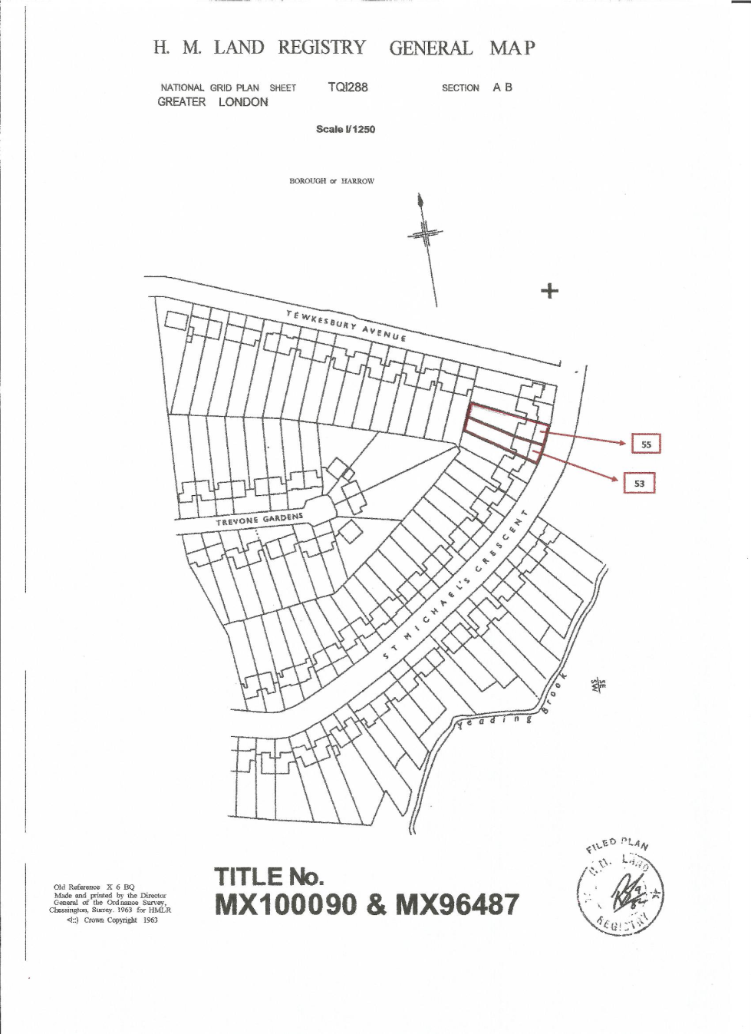

APPENDIX 3: Site Photographs

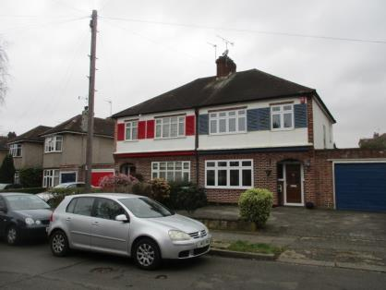
Front Elevation of 53 and 55

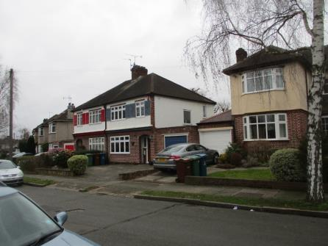
Looking towards front of 57 (right) and 55 (left, blue garage)

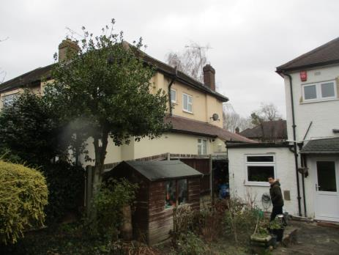
Looking towards side of 57

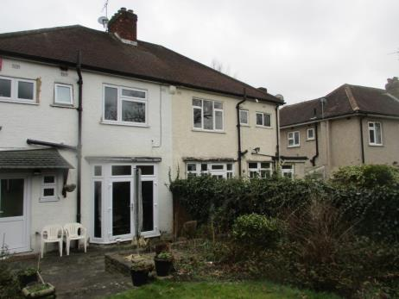
Looking towards rear of 53

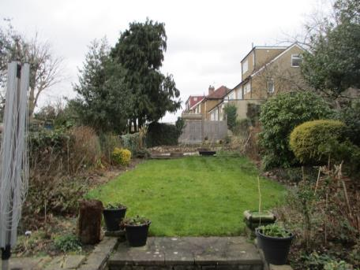
Rear garden

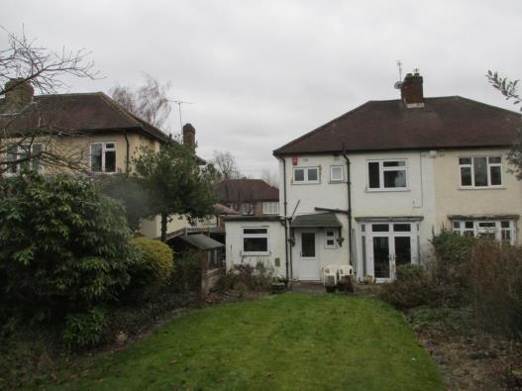
Rear of 57-53 (left to right)

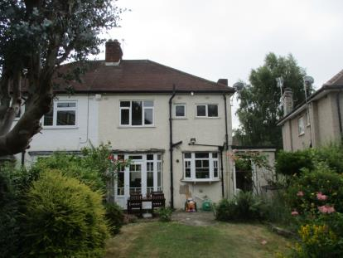
Rear of 53 – no. 51 to the right

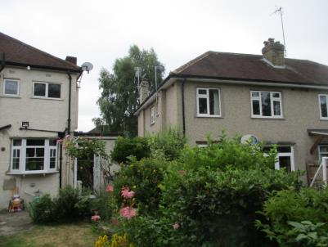

Looking towards rear of 51

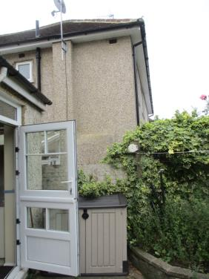
Staggered building line between no. 53 and 51

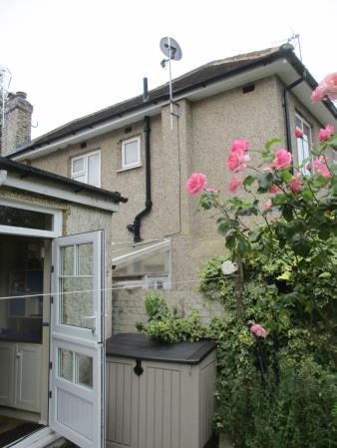
APPENDIX 4: Plans and Elevations

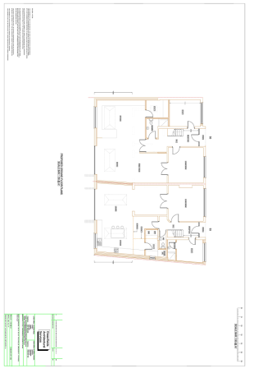
Proposed Ground Floor

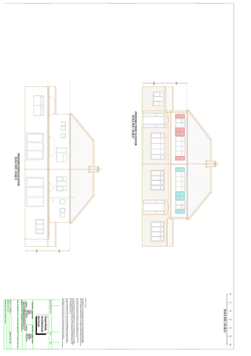

Proposed Front and Rear

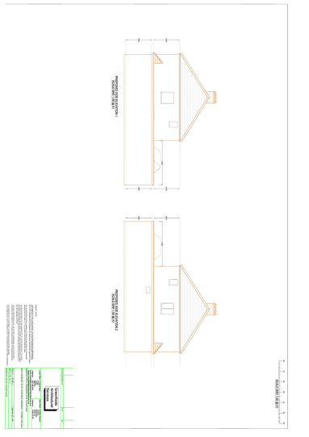

Proposed sides

This page has been left intentionally blank

